In 1066, William (in French « Guillaume le Conquérant ») invaded England with the Norman army. William the Conqueror won the battle of Hastings and became king of England. William and his knights spoke French.
Watch the cartoon and do these exercises:
- Relie ces mots avec des flèches :
Mutton Old English the king and queens
Sheep French the nobility
the peasants
- Relie chaque mot à l’animal correspondant :
Cow 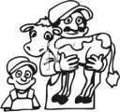
Pig 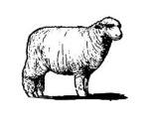
Calf 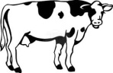
Sheep 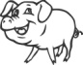

- Ecris en haut de la bonne colonne, “the animal in the field” et “the meat”; puis classe les mots suivants.
Veal –cow - pig- pork – calf – beef – mutton - sheep
Mots d’origine anglo-saxonne:  ___________________________________ | Mots d’origine française:  ___________________________________
……………………………………………………………………………………  …………………………………………………………………………………… | …………………………………………………………………………………….  ……………………………………………………………………………………

- Classe les mots suivants selon leur origine: army, kitchen, battle, classroom, soldier, religion, house, woman, dog, liberty, parliament, Tuesday, judge, justice
Mots d’origine anglo-saxonne: | Mots d’origine française:
……………………………………………………………………………………  ……………………………………………………………………………………  …………………………………………………………………………………… | …………………………………………………………………………………….  ……………………………………………………………………………………  ……………………………………………………………………………………

